

**COMPUTER NETWORKS**

**ASSIGNMENT 03**

**Group Members:**

i) Bilal Ahmed Khan (20k0183)

ii) Muaaz Alam (20k0212)

**Task:**

**Develop the reliable data transfer protocol (rdt 3.0). For the sake of simplicity consider only uni-directional data transfer, but the control information will flow on both directions. You may use the finite state machine (FSM) of the rdt 3.0 to understand all the states, events and actions.**

**Note:**

**You need to implement stop and wait protocol where only a single packet is in-flight. Further the size and count of packets to be transferred should be configurable. You can also assume a fix timeout period.**

**Solution:**

1. Server Running:

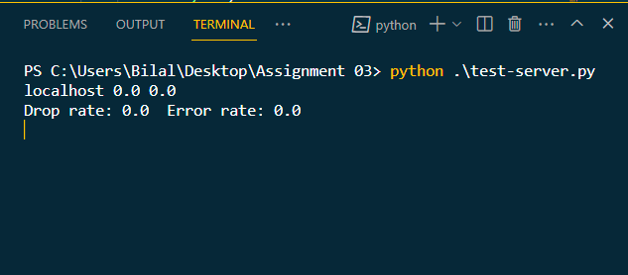

1. Client Sending File:

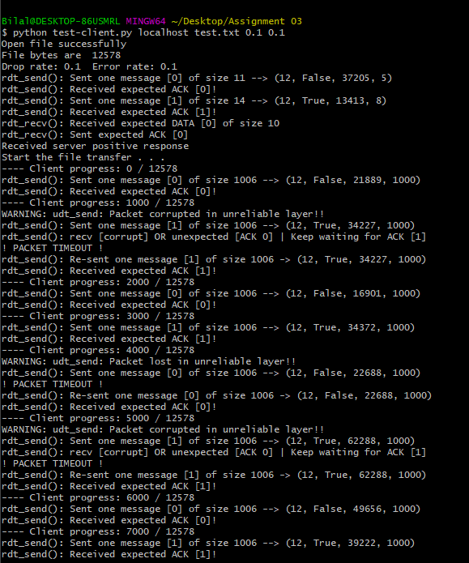

1. File completely sent from client side

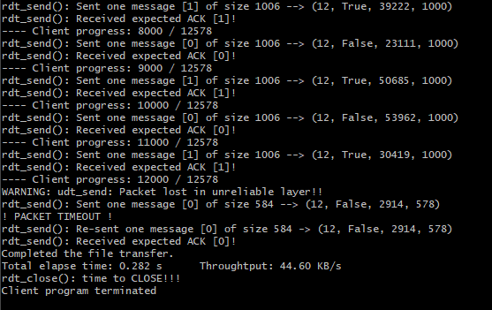

1. File completely received by server

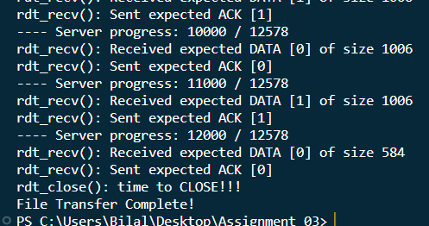

1. File showcased in folder:

